SCUBA-2 Block Specification
clk_card

Created on: 7 October 2005
Last saved on: 07 October 2005
Table of Contents

1. Block Description 3
1.1 Block Hierarchy 3
1.2 Block Overview and Features 3
1.3 Detailed Description 3
2. Interface Description 5
2.1 Signals Description 5
Files Associated with this Block 7

Block Description
The clk_card is the top-level block in the hierarchy of the RTL-level code for the Clock-card FPGA.

Block Hierarchy
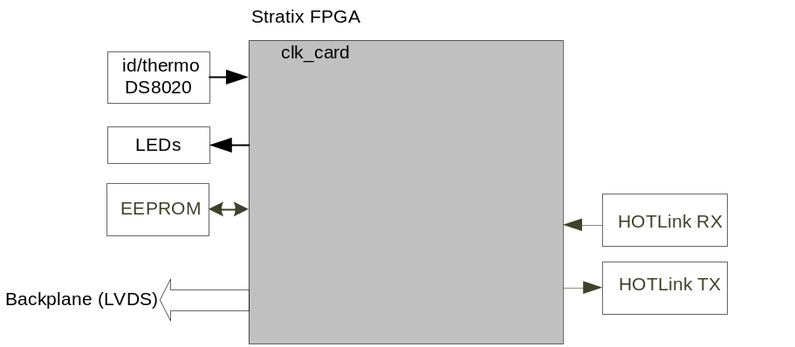
Figure 1: clk_card Block Location Within the System

Block Overview and Features
The clk_card top level communicates to the external devices including the HOTLink receiver/transmitter chips, id/thermo chip, and EEPROM. The incoming commands through the fibre link are decoded and distributed to the appropriate card for proper action. Clock_card also dictates the timing of events to all the cards by generating a clock signal and a sync signal.

Detailed Description
The Wishbone bus protocol (refer to Wishbone Specification) is adopted as inter-block communication standard between the different blocks in clk_card. One block, in this case dispatch, acts as Wishbone Master and the other blocks are Wishbone slaves. Commands are received along the fibre through issue_reply block and then issued to the backplane. The commands coming through the backplane LVDS line is then decoded by the Wishbone Master and communicated to the relevant Wishbone Slave through the Wishbone protocol.
The following blocks are instantiated in clk_card block:
- issue_reply:
  - .
- sync_gen:
  - This block generates the sync signal to be sent over the backplane.
- ret_dat_wbs:
- cc_reset: This block monitors the fibre independent of the issue_reply block and when certain character is encountered over the fibre, it triggers a reset to all the cards by pulling one of the TTL
- dispatch:
  - Receives and decodes the incoming backplane commands
  - Delivers the wishbone-formatted command to the appropriate wishbone slave
  - Converts the wishbone reply to backplane format and transmits the reply over the backplane.
- id/thermo: A wishbone slave to read the card-id and the temperature from the DS8020 chip
- leds: A wishbone slave to controls the 3 LEDs
- fw_rev: A wishbone slave to return the firmware revision
For more information, refer to the documentation for each block.

clk_card
sync_gen

leds
dispatch
fw_rev
id_thermo

Figure 2: clk_card Block Diagram (INCOMPLETE)

Interface Description

Signals Description
 | Description | Direction
Global Signals
rst_n | Global reset signal | In
Inclk | PLL input clock | in
Fibre Hot Link Interface
fibre_rx_clk | reference clock for the clock/data synchronizing PLL of the Hotlink chip. | out
fibre_rx_data | parallel 8-bit data of the Hotlink receiver chip | in
fibre_rx_rdy | Hotlink receiver data-ready signal, 0 indicates that new data is received and is ready. | in
fibre_rx_rvs | Hotlink receive-violation symbol, 1 indicates a code rule violation is detected. | in
fibre_rx_status | 1 indicates a carrier detect over the fibre. | in
fibre_rx_sc_nd | Special_character/Data Select, 1 indicates a control character is received over the fibre and 0 indicates a data is received. | in
fibre_rx_ckr | Hotlink receive clock that is phase and frequency aligned to the incoming serial data over the fibre | in
fibre_tx_clk | reference clock for the Hotlink transmitter PLL | out
fibre_tx_data | parallel 8-bit data to be transmitted by the Hotlink transmitter | out
fibre_tx_ena | 0 on the rising edge of fibre_tx_clk indicates that fibre_tx_data is ready to be latched and transmitted. | out
fibre_tx_sc_nd | Special_character/Data Select, 1 on rising edge of fibre_tx_clk causes the transmitter to encode fibre_tx_data as a control code, while 0 causes the data to be coded using the 8B/10B data alphabet. | out
LVDS Interface
lvds_cmd | command line to the backplane (going to all the cards) | out
lvds_sync | sync signal to the backplane (going to all the cards) | out
lvds_spare | connected to a spare backplane LVDS line for future use | out
lvds_clk | 25MHz clk to the backplane (going to all the cards) | out
lvds_reply_ac_a | Address card primary reply line (through the backplane) | in
lvds_reply_ac_b | Address card secondary reply line (through the backplane, not used at this time) | in
lvds_reply_bc1_a | Bias Card 1(BC1) primary reply line (through the backplane) | in
lvds_reply_bc1_b | Bias Card 1(BC1) secondary reply line (through the backplane, not used at this time) | in
lvds_reply_bc2_a | Bias Card 2(BC2) primary reply line (through the backplane) | in
lvds_reply_bc2_b | BC2 secondary reply line (through the backplane, not used at this time) | in
lvds_reply_bc3_a | BC3 primary reply line (through the backplane) | in
lvds_reply_bc3_b | BC3 secondary reply line (through the backplane, not used at this time) | in
lvds_reply_rc1_a | RC1 primary reply line (through the backplane) | in
lvds_reply_rc1_b | RC1 secondary reply line (through the backplane, not used at this time) | in
lvds_reply_rc2_a | RC2 primary reply line (through the backplane) | in
lvds_reply_rc2_b | RC2 secondary reply line (through the backplane, not used at this time) | in
lvds_reply_rc3_a | RC3 primary reply line (through the backplane) | in
lvds_reply_rc3_b | RC3 secondary reply line (through the backplane, not used at this time) | in
lvds_reply_rc4_a | RC4 primary reply line (through the backplane) | in
lvds_reply_rc4_b | RC4 secondary reply line (through the backplane, not used at this time) | in
EEPROM Interface
eeprom_si | Incoming serial data from eeprom as part of the SPI interface | in
eeprom_so | Outgoing serial data to eeprom as part of the SPI interface | out
eeprom_sck | Serial clock for eeprom (SPI interface) | out
eeprom_cs | Chip select for eeprom (SPI interface) | out
TTL Interface (X 3 for TTL1 to TTL3 spare lines)
*Note: ttl1 line is used to issue the global firmware reset originated from the RTL PC to the other cards)
ttl_txena1 | controls the direction of the spare TTL line | out
ttl_nrx1 | input TTL spare line controlled by ttl_txena1 | in
ttl_tx1 | output TTL spare line controlled by ttl_txena1 | out
LED Interface
red_led | Red LED data | out
ylw_led | Yellow LED data | out
grn_led | Green LED data | out
Miscellaneous
dip_sw3 | dip switch 3 data | in
dip_sw4 | dip switch 4 data | in
wdog | watchdog | out
slot_id | 4-bit data hard-wired per slot on the backplane | in
card_id | single-wire interface to the on-board ds8020 id/temperature chip | in
test | 32-bit PTH test header | out
mictor_o | 16-bit data for the logic analyzer (odd side) | out
mictorclk_o | mictor clock for the logic analyzer (odd side) | out
mictor_e | 16-bit data for the logic analyzer (even side) | out
mictorclk_e | mictor clock for the logic analyzer (even side) | out
rs232_rx | Debug port | in
rs232_tx | Debug port | out

Files Associated with this Block

File | Description
clk_card.vhd | top-level
clk_card_pack.vhd | pack file for clk_card.vhd including definition of some of the constants
tb_clk_card.vhd | Testbench for clk_card top-level

